**CSC 110 2.0 Object Oriented Programming**

**Final Assignment – 2023**

Software Design Document

Index – AS2021367

Name – T.G.D.S.Chathuranga

Class Diagram

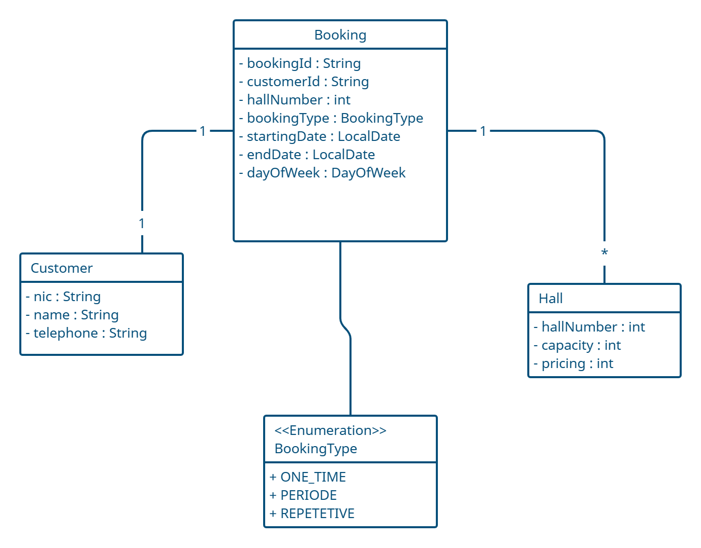

Usecase Diagram

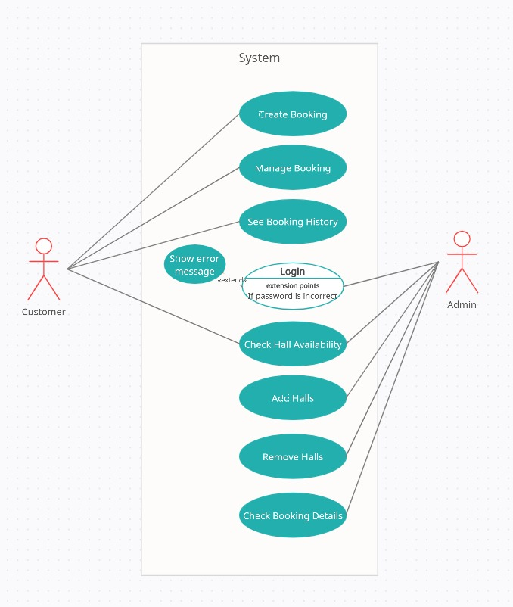

Database Design

